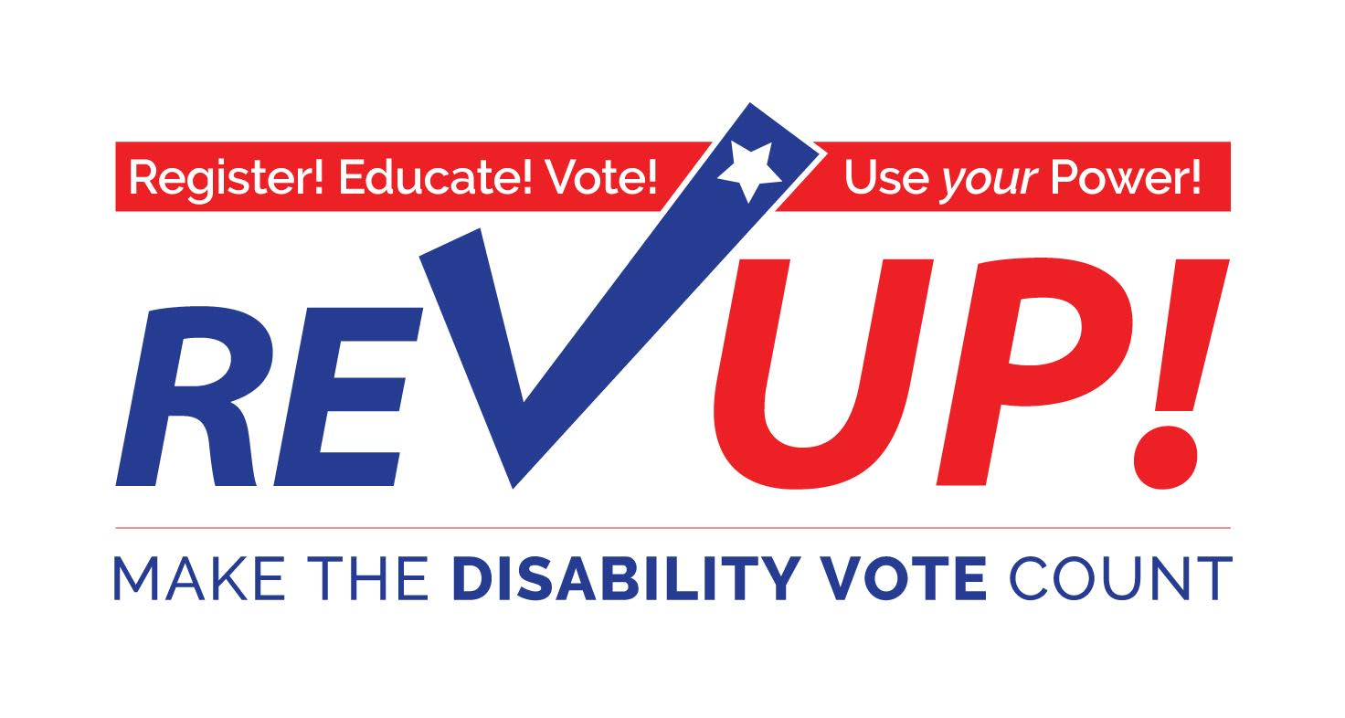

**“Vote as if your life depends on it—*because it does*!”**

# -Justin Dart, Jr., father of the ADA, Texan, patriot

***The November 8th election will be one of the most important elections you can vote in.***

## The disability community—people with disabilities, family members, attendants, providers, professionals, advocates and supporters—has a major stake in the outcome of this election.

The ***Disability Vote!*** Can make a difference on issues such as:

|  |  |
| --- | --- |
| * Adequate funding and coverage for Medicaid acute and long term services | * Adequate funding for quality public and higher education |
| * Waiting lists for home and community services | * Quality Medicaid managed care with strict accountability measures |
| * Consolidation and closure of public institutions | * Implementation and enforcement of the “most integrated setting” requirements in the Americans with Disabilities Act (ADA) |
| * Integrated employment at no less than minimum wage | * Accessible, affordable, and integrated housing |

**I pledge to VOTE on November 8!**

# Name: ______________________________________________________________________

Address: ____________________________________________________________________

City: ______________________________________ State: ________ Zip: ________________

Email: ___________________________________________ Phone: _____________________

More Resources at:

[**www.aapd.com/REVUP**](http://www.aapd.com/REVUP)